June 26, 2019 will be Colorado Springs’ 26th Annual Bike to Work Day sponsored by KOAA News 5 and the Colorado Springs Independent! Bike to Work Day encourages bicycling for transportation, personal and community health, recreation and sustainability. Breakfast locations along our bicycle network are designed to support how people actually ride their bikes to work while highlighting local businesses that support bicycling in our community. This year will again include multiple locations throughout the city supported by the community. Bike to Work Day has introduced many folks, often for the first time, to bicycle commuting. It also offers a fun and festive way to connect with the community through bicycle commuting. This toolkit guides station organizers through the process of planning, equipping and marketing their station for a successful and rewarding Bike to Work Day event. Questions regarding breakfast stations can be emailed to btwdbreakfast@springsgov.com.

Once you have reviewed the information below and are ready to commit to hosting a station for this year’s event, please register your station online. We want to give participants a good idea of where your station is and what you are offering, so they can know what a great job you do supporting people on bicycles and be sure to visit! You can submit your application for a breakfast station even if you don’t have all the information on breakfast offerings, giveaways, etc. If you completed the station application you can provide additional information by completing the application again, with your organization name and any new information, and we will do our best to merge the information. PLEASE NOTE: May 24 is the deadline for getting your information onto digital or print materials in advance of the registration push. we will do our best with anything received after that, but no guarantees.

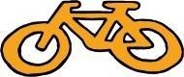 What is Bike to Work Day?
Bike to Work Day is a statewide endeavor to provide a fun, encouraging and enticing day for people to try a bike commute. Bike to Work Day is an opportunity for those who bike to work often as well as first-timers to commute as part of a positive and supportive event. It is also an opportunity for bicycle riders to support the local businesses who support us, and for bicycle riders to demonstrate that they are a market. We hope that event participants will bike to work and retailers more frequently following the event. Their commitment positively affects regional air quality, health and traffic congestion, and ultimately promotes economic growth in our community.

Why should you organize a Bike to Work Day station?
Bike to Work Day is an opportunity to promote your business and connect your brand with a positive, healthy, community-oriented event. Bike to Work Day stations are organized by volunteers who use the event's positive reputation to promote their business, support their community and gain visibility. Although products for sale and services-for-fee are prohibited at Bike to Work Day breakfast stations, many businesses use their stations to provide samples of new products and services, provide coupons for future purchases or explain their organization and brand. You can also use the opportunity to encourage your staff and customers to ride their bicycles and enjoy the economic, health and enjoyment benefits of doing so. Stations keep Bike to Work Day participants in good spirits and provide opportunities for bike commuters to rest, socialize, and refuel.
#1
Identify your station location
Event organizers wish to make sure that locations are convenient and well-attended. We recommend your organization hosts near a trail location or existing on-street infrastructure. If your business is not near bicycle facilities, consider moving it to a more convenient location and create fliers and signs that emphasize your business location and offer incentives (promotions, coupons, etc) to participants to visit your business location at a separate time. When you register your station online, City staff will review your proposed location and may suggest a revised location for safety or logistical reasons.

#2
Determine your station scope (and solicit support if needed!)
All stations (breakfast or grab ‘n go) must be open for the morning ride from 6 - 9 a.m. Stations are required to provide free food and beverage (plus water) for 50 - 100 riders (Bike to Work Day organizers will work with you to estimate the correct amount based on location and past performance.). Again this year, there will be recognition for “best of” stations (and prizes!), so bring your a-game! Breakfast stations can make a memorable impression by offering great food and more – things like entertainment, games, raffle prizes, vendors, etc…. Here are a couple examples of the range of station types that might be offered.

Example 1: “Party” Station:
May require several tables, seating, shade tent, speakers, and 4-10 volunteers.

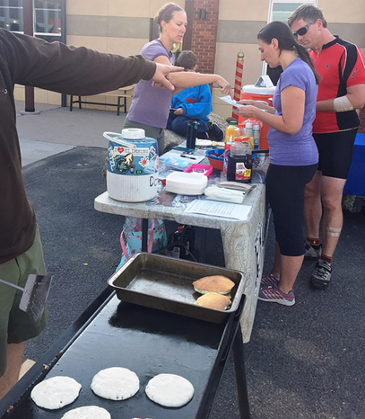
Food & Beverage
- Breakfast burritos
- Pastries
- Fruit salad
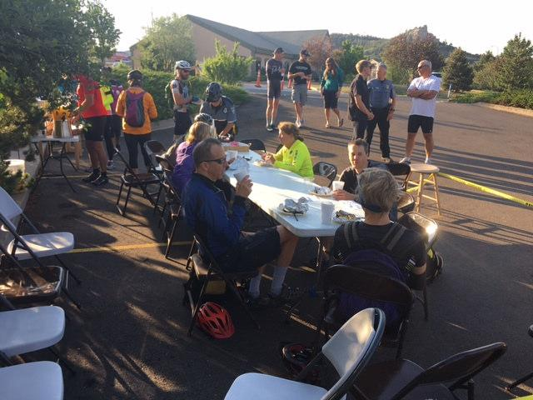
- Yogurt and Granola
- Pancakes, french toast
- Eggs and bacon
- Juice, coffee, smoothies

Prizes
- Bike jerseys
- Bike panniers
- Coffee gift cards
- Hotel packages
- Restaurant gift cards

Giveaways
- Coupon or incentive to encourage participants to return to your location by bike
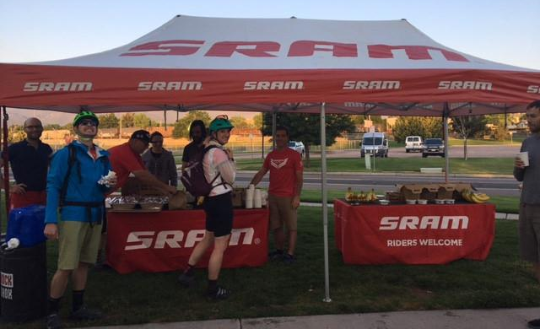
- Courtesy kit (tissues, bandages, wipes)
- Bells
- Buttons/pins, key chains, pens
- Tire patch kits

Entertainment
- Large-scale games
- Local musicians
- Yoga or stretching sessions
- Pedal-powered smoothies
- Chair massage

Example 2: Grab ‘n Go Station:
If you have limited capacity, consider offering a more “grab ‘n go” style station. Anticipate brief stops by participants with items that can be easily stored for the remainder of their commutes. Ensure your grab ‘n go items are branded with your organization’s logo or website so participants remember where they stopped along the way. And we recommend you include a giveaway of some sort with your offering.
Likely requires 1-2 tables, a couple of chairs and 2-3 volunteers
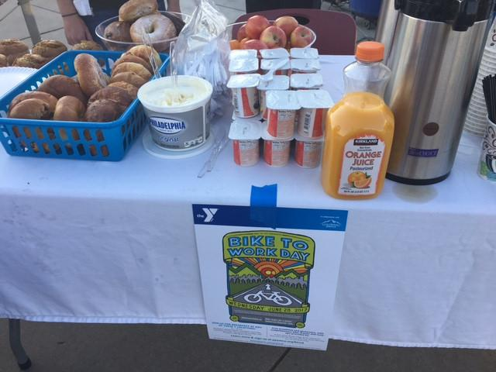
Food & Beverage

- Bagels
- Bananas, apples, oranges
- Bars
- Popcorn (bagged)
- Squeezable yogurt
- Juice, coffee

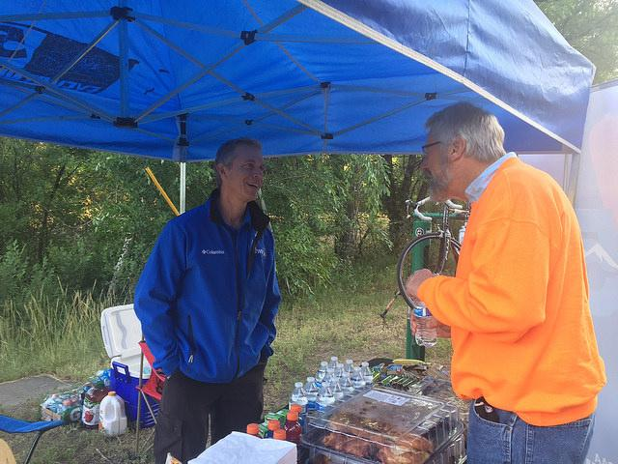

Whatever style of station you offer, the easiest way to make planning easy and fun is to gather a group of interested people – a committee. Planning with a group is a great way to share responsibilities to make sure that you are able to host a successful and memorable station. Below are some ideas to consider.
- Wayfinding signs help riders find your station, and also increase your brand by promoting your involvement in Bike to Work Day where all travelers will see the message. Even if you feel as though riders couldn't possibly miss your station, the most successful stations incorporate wayfinding signage into their station logistics, and direct riders to their station from every possible route.
- A table (or tables) is (or are) required for your station to help you provide food, drink, and other station offerings to riders. Chairs are helpful for volunteer comfort, and chairs for riders would be considered a bonus.
- Volunteer staff is imperative to a successful station. Volunteers are the face of your station: They greet riders, distribute food and giveaways, and also help set up and take down the station.
- Bike parking is required for all stations. Many stations use a simple barrier that allows bikes to be held upright when parked with a kickstand or propped up by the front wheel. If you have access to a large grassy space, participants can also use this area for overflow bike parking.
- Tents or canopies are beneficial, although not required. Tents and canopies are highly visible and help riders and other travelers spot your station. Tents and canopies are also beneficial for the shade they provide – in June, sunrise is before 6 a.m. and stations warm up quickly.
- A station theme is a great way to make your station fun and memorable.
- Bike techs can be great partners for your station. Bike techs help participants who experience breakdowns or mechanical failures during their ride. Talk to a local bike shop to see if they can support your station with a bike tech.
- Pack out what you brought in and be sure to get all of your trash picked up.

#3
Station logistics
Please consider carefully how you will organize your space to serve people quickly without blocking the right of way. Consider where participants should leave their bikes and how you can provide parking. If you are hosting a Bike to Work breakfast station at your place of business, please take care to make sure Bike to Work participants can distinguish between the breakfast station (where food and beverages are free) and any food and beverage for sale through your usual operations.

Leading up to Bike to Work Day, begin preparing supplies for your station. Here are some additional things to consider:
- Sunscreen
- Towels
- Broom
- Garbage, recycling and composting receptacles, trash bags
- Tape Rope and bungee cord
- Weights (a variety of sizes may be necessary, small to keep tablecloths or napkins from blowing away, larger for other items)
- Umbrellas and waterproof containers (in case of a quick downpour)
- Hand sanitizer
- Pens and paper
- Scissors or a box opener

#4
Get the word out!
Start letting people know that you are going to provide a breakfast location for Bike to Work Day 2019. Use your social media tools (Facebook, Twitter, Pinterest, Instagram, LinkedIn…) to start talking it up to your employees, your customers, and the public. Do a press release, contact local media and invite them out. Use newsletters and flyers to communicate. Be creative! The City will also provide regular event-promoting language to share so keep an eye out for that.

We want to share your logo and your business with our riders! If you are a new breakfast station sponsor please email a high-resolution version (vector file/ print logo/300 dpi/.eps file) to btwdbreakfast@springsgov.com to ensure a high quality image on our yard signs.
PLEASE NOTE: June 10 is the absolute drop-dead deadline for getting your logo onto the yard signs for the day of the event. If you do not get us your logo by that point, you will still have yard signs, but they will be text only.

