* Approximately 800 individuals have been part of the North Nevada master plan process; a vision for the area and concepts are currently being drafted
* Continue to work towards an Innovation District with educational, business community, and small business development leaders
* Continue to actively participate in key military events
* Partnering with Airport Administration and El Paso County Economic Development to designate and re-incorporate Foreign Trade Zones within the CAZ
* City Council approved a CSFD Division of the Fire Marshal-recommended Fire Code Amendment on Flora regulation
* Installed demonstration buffered bike lanes along Research Parkway
* The board of the Colorado Springs Downtown Development Authority gave unanimous approval to the Experience Downtown Plan of Development and Master Plan, setting forth a clear vision for the economic and physical development of the city center
* Worked with Catalyst Campus on their grand opening
* Working with 1 Million Cups to strategize about overcoming entrepreneurial challenges and streamlining processes when collaborating with the City
* Participating in the community, collaborative workforce asset group
* Working with the CVB and Pueblo leadership on promoting tourism and the Colorado Springs Airport on a regional level

**2016 THIRD QUARTER PROGRESS:**

*Create an environment that promotes job creation and stimulates strong, diverse and sustainable economic development and opportunity for all of our citizens*

**PROMOTING JOB CREATION**

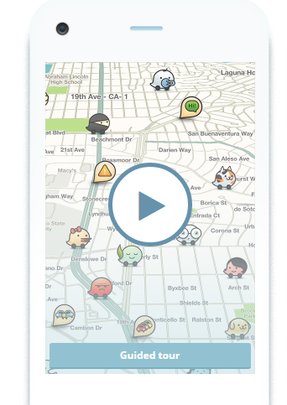

**YEAR-TO-DATE 2C STATISTICS:**

* Paved 183 lane miles
* Replaced 75,136 linear feet of curb and gutter
* Replaced 133,447 square feet sidewalk
* Installed 201 new pedestrian ramps
* Retrofitted 166 existing pedestrian ramps
* Placed more than 98,265 tons of asphalt
* Crews reached a major milestone in the emergency replacement of the Chestnut Bridge today as the concrete arches were placed
* 183 lane miles paved by voter-supported 2C with 215 lane miles being completed by end of 2016
* Undertaking flood mitigation work that protects Garden of the Gods and Rock Ledge Ranch and downstream areas largely through grant funding
* Began public process for the City’s Comprehensive Plan
* The City of Colorado Springs announced a data-sharing partnership with the Waze navigation app to keep citizens and road work crews safe around 2C construction

**INVESTING IN INFRASTRUCTURE**

*Maintain and preserve the City’s vital infrastructure and assets*

**2016 THIRD QUARTER PROGRESS:**

**BUILDING COMMUNITY & COLLABORATIVE RELATIONSHIPS**

* Money Magazine has named Colorado Springs one of its six “Best Big Cities”
* Mountain Metropolitan Transit (MMT) was honored to receive the Colorado Association of Transit Agencies (CASTA) Large Community Transit Agency of the Year award
* MMT added service; including Saturday, Sunday and evening service to select routes; and frequency on select routes
* More than 225 volunteers from CarMax, Colorado Springs Parks, Recreation and Cultural Services, organizers from KaBOOM! and Colorado Springs residents built a playground in Cheyenne Meadows Park in six hours.
* Partnered with Colorado Springs Utilities for Creek Week
* Neighborhood services held successful neighborhood cleanup (43 of 51 member homes participated)
* The CSFD started a recruit academy of 22 firefighters on August 22
* CSPD's 39 newly graduated police recruits are in field training
* Moved some specialized unit offers to patrol to address response time issues
* CSFD Wildfire Mitigation Office treated 277 wildland acres for a year-to-date total of 991 acres
* OEM hosted a Joint Information System discussion a workshop to gain input on the Colorado Springs Recovery Plan and partnered with other agencies on resiliency and mitigation planning
* Worked closely with SportsCorp for most well-attended Downtown Olympic Celebration to date

**2016 THIRD QUARTER PROGRESS:**

*Celebrate and connect community through ongoing dialogue with our citizens and local, regional, and state leaders to reach mutual goals, and by encouraging private sector and non-profit initiatives that improve the well-being of everyone*

**EXCELLING IN CITY SERVICES**

*Ensure a fiscally sustainable and resilient City that delivers consistent quality services and continuously seeks to improve service delivery*

* Pikes Peak Summit complex team applying for a Living Building Challenge™ Certification
* Participating in ongoing Community Partnership Initiative meetings with military installations to identify collaboration opportunities
* Expanding the City’s supervisor/manager training program
* Additional meetings with key staff to use implement digital review and routing for the development review process
* Conducting internal process improvements to continually improve the City’s efficiency and effectiveness
* Facebook followers rose by 9.77%; Twitter followers: rose by 14.66%; Generated 2,000 Instagram followers

Learn more about the City’s Strategic Plan at:

Cosprings.gov/strategicplan

Thank you to our community partners for joining us in achieving our shared goals!

**2016 THIRD QUARTER PROGRESS:**